**Shri-harsha**

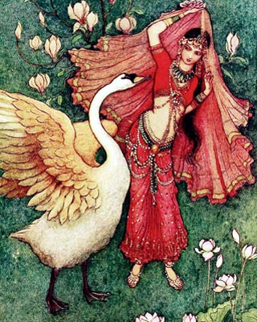

**Shri-harsha** was a 12th century [Sanskrit](https://www.wikiwand.com/en/Sanskrit) very intelligent philosopher, bhakt, poet from India. He was so intelligent that he challenge to find mistake in his poet to goddess Sarswati.

**Early Life**

Śrīharṣa was the son of Śrīhira and Mamalladevī. His father, Śrīhira, was a poet in the court of the [Gahadavala](https://www.wikiwand.com/en/Gahadavala" \o "Gahadavala) king [Vijayachandra](https://www.wikiwand.com/en/Vijayachandra). His father was also guiding and diverting common people towards god with veda's, Bhagavad Gita's thoughts. His father asked Harsha at the time of death to study well and become pandit. Then, use his shiksha (education) towards making life of people divine and better. Also, asked to take thoughts of Bhagavad Gita to every one. Harsha went to gurukul for education and study under Guru's guidance. He mastered all scriptures and all schools of thoughts prevailing at that time. He wrote unparalleled book (granth), खण्डन-खण्ड-खाद्य, on advait vedant.[  In this book, he has refuted Nyayadarshan's principals.

## **Naishadha Charita**

Śrīharṣa composed the poem (*kāvya*) [*Naishadha Charita*](https://www.wikiwand.com/en/Naishadha_Charita) ([IAST](https://www.wikiwand.com/en/IAST): *Naiṣadhacarita*) in 1174, during the reign of the Vijayachandra's son [Jayachandra](https://www.wikiwand.com/en/Jayachandra). According to Rājaśekhara's *[Prabandhakośa](https://www.wikiwand.com/en/Prabandha_Kosha" \o "Prabandha Kosha)*, upon the wide acceptance of *Naishadha Charita*, Śrīharṣa was dignified with the title *Narabharati*.

The *Naishadha Charita* contains erotic themes, but according to the 15th-century Jain scholar [Nayachandra Suri](https://www.wikiwand.com/en/Hammira_Mahakavya" \o "Hammira Mahakavya), Śrīharṣa was actually a celibate, who had "conquered his sense organs" (*jitendriya*).

The *Naishadha Charita* was brought into Gujarat by Harihara during the reign of [Vīradhavala](https://www.wikiwand.com/en/Vaghela_dynasty" \l "Viradhavala" \o "Vaghela dynasty) to which Chandu Pandita in his *Dipika*, composed in 1296, refers to as a new poem and also to the commentary of Vidyādhara. *Naishadha Charita* was composed earlier than *Khaṇḍanakhaṇḍakhādya* in which text Sriharsha alludes to the works of [Kalidasa](https://www.wikiwand.com/en/Kalidasa).

**Other Works**

Śrīharṣa spent his later life in ascetic serenity on the banks of River Ganga. He composed several other works, none of which are now available. These include *Vijayaprasasti*, *Chindaprasasti*, *Gaudorvisakulaprasasti*, *Sahasankacarita*, *Arnavavarnana* and *Amarakhandana* are now available. His *Khaṇḍanakhaṇḍakhādya* is a critique of the *Śivabhaktisiddhi* by [Udayana](https://www.wikiwand.com/en/Udayana), the [Nyāya](https://www.wikiwand.com/en/Nyaya" \o "Nyaya) philosopher.

Śrīharṣa was also a philosopher; *Khaṇḍanakhaṇḍakhādya* or "Sugar-candy pieces of refutations," is a refutation of the doctrines of the *Nyāya* system of philosophy.